Intro to SQL Server Management Studio (SSMS)

(You have to do the first part only if you have not restore the Adventurework2019 database yet)

1. Download AdventureWorks sample database from Microsoft website (2019 version->Adventure Works 2019 Full Database Backup.zip)

<https://docs.microsoft.com/en-us/sql/samples/adventureworks-install-configure?view=sql-server-ver15&tabs=ssms>

**You can also download it from your school’s portal (Microsoft Teams).**

1. Download the [AdventureWorks2019.bak](https://github.com/Microsoft/sql-server-samples/releases/download/adventureworks/AdventureWorks2019.bak)
2. You will need to either put the file in a path that SSMS will know or leave it where it is and have permissions issues. As I am the administrator on my own system, I will put the file where all .bak files go, in the folder:

D:\Program Files\Microsoft SQL Server\MSSQL13.MSSQLSERVER\MSSQL\Backup

**Note this is MY SYSTEM NOT yours so the folder you created for the SSMS might be different.**

The image below shows where SQL Server will look for all .bak files.

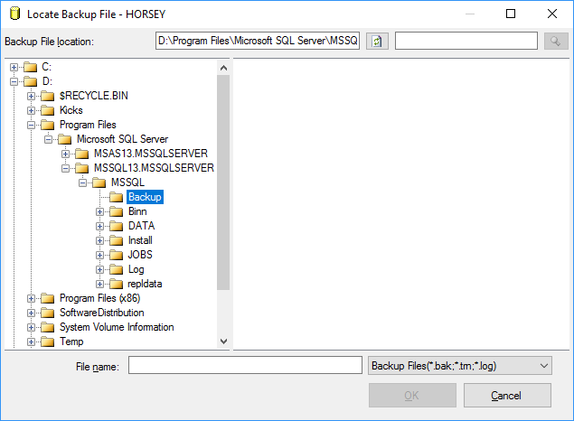

The image below shows the end-result of restoring the .bak file, we will still need to refresh in order to see the actual tables and values etc.

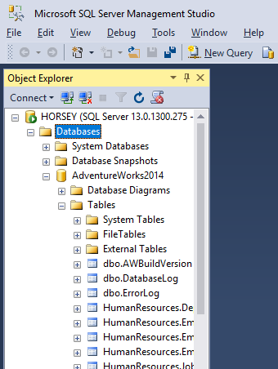

Tasks:

1. Try to find all registered servers on your system; *hint its under views.*
2. Disconnect from the current server and then connect again*; hint you can use Object Explorer.*
3. Display the query window, this is where you will be doing most of your work.
4. Open the **Properties** window. (There is a shortcut you can use. Find it.)
5. Display then hide, the **Object Explorer Details** page; *hint F7.*
6. Configure your environment to open the **Query Window** when SSMS starts, test it. Is it possible to change the Background? Do a little research on Internet.
7. Now restore everything you just did by restoring to default: *hint, Reset Window Layout.*
8. Disk Usage by Table for your AW db is always a good statistic to see how your db is doing in terms of disk space, try it:  
     
   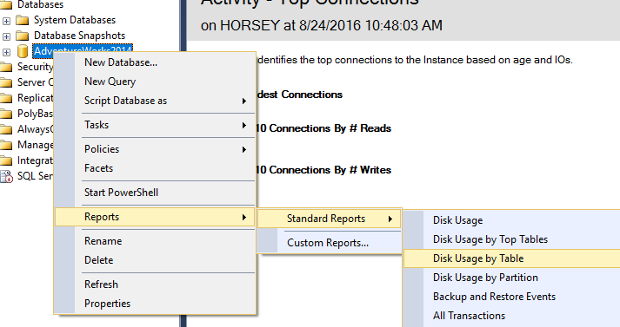

NOTE: this report is about the AdventureWorks db **NOT** the Server.

1. Now look for *Top Transactions by Age*. Of course we do not have any as yet, but now go back to just *Reports* and see if you **notice** something about the options you have now, compared with when we started!  
   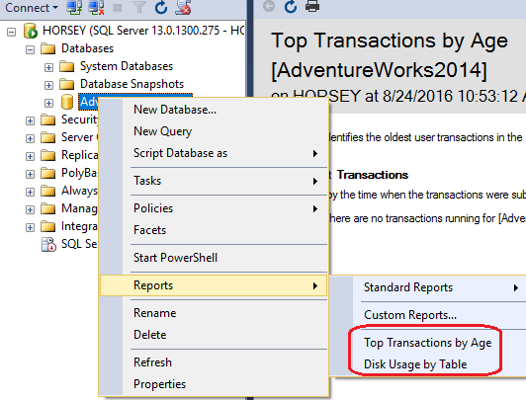
2. Attempt to find and run the *Activity Monitor*.
3. In OE (Object Explorer), go down to *Management -> SQL Server* Logs and take a look at the current logs (view server logs) Do you remember what the last thing we did on the server? It should show up here.
4. Right-click AW db and look at it’s properties. Once there look at Files (under general) there is no owner! Now, attempt to Create a DB Diagram  
     
   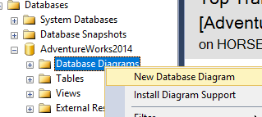

You should get a warning message, about permissions. Well it is because we have no owner yet. Now go back in to Properties of AW and enter the owner, the image below shows MY system. We will try it again when teaching Database Diagrams.  
  
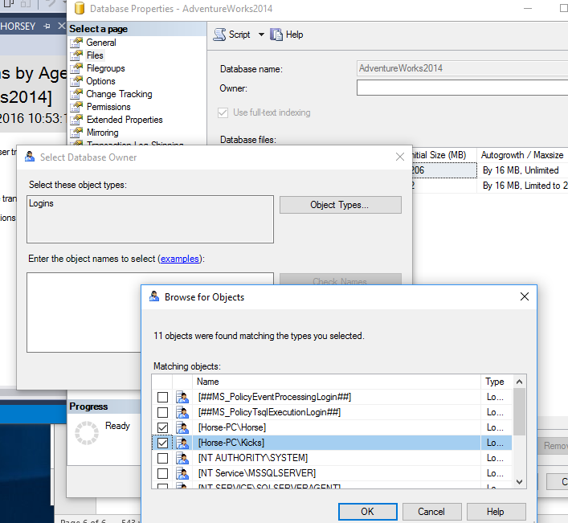

1. Check out Options in this same area (DB Properties).

Congratulations. If you did all the steps above, it means you are ready to write more complex queries in the next weeks.